**PROJECT DOCUMENTATION**

COOKBOOK: Your Virtual Kitchen Assistant

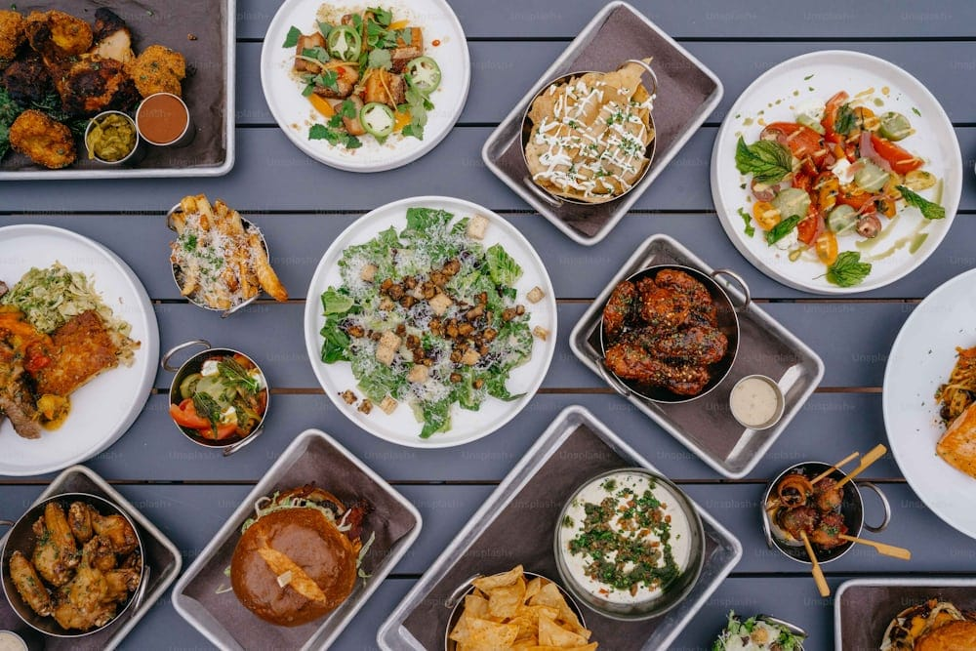 **Project Title:** COOKBOOK: Your Virtual Kitchen Assistant

**Team ID: NM2025TMID36512**

**TeamLeader:**

* **Kirthika. G- 24cskirthika0046@gmail.com**

**Team Members:**

* Keerthana. S- [24cskeerthana044@gmail.com](mailto:24cskeerthana044@gmail.com)
* Keerthana. K-  [24cskeerthana042@gmail.com](mailto:%2024cskeerthana042@gmail.com)
* Keerthika G.V- [24csgvkeerthika045@gmail.com](mailto:24csgvkeerthika045@gmail.com)

**Project Overview**

**Purpose:**

The primary purpose of a cookbook is to serve as a culinary reference work that provides a collection of recipes and instructions for preparing food. While this is the core function, the project purpose of a cookbook can be much broader and more specific, depending on the author and the intended audience.

Here are some common project purposes for a cookbook:

**Preserving and Sharing Family History**

A cookbook can be a way to document and pass down family traditions and recipes. It can tell a story about a family's heritage, cultural background, and the memories associated with special dishes. This type of cookbook is often created for a small, intimate audience of family members and friends.

**Showcasing a Specific Cuisine or Skill**

Authors may write a cookbook to highlight a particular style of cooking, such as vegan, gluten-free, or a regional cuisine. The purpose is to provide a comprehensive guide to that topic, including not just recipes, but also cooking techniques, ingredient information, and cultural context.

**Supporting a Business or Brand**

For chefs, restaurants, or food-related businesses, a cookbook can serve as a powerful marketing tool. Its purpose is to showcase the brand's unique culinary philosophy, provide customers with a souvenir, and expand the brand's reach beyond its physical location.

**Fundraising for a Community or Cause**

Many community groups, schools, and non-profit organizations create cookbooks to raise money. The purpose of this project is to gather recipes from community members, create a product that brings people together, and generate funds for a specific cause.

**Teaching and Educating an Audience**

A cookbook can be an educational tool designed to teach a specific skill or concept. This could be anything from basic cooking techniques for beginners to advanced methods for professional chefs. The purpose is to provide a structured, step-by-step guide that helps readers master a particular area of cooking.

**Features:**

A cookbook is a structured document with a variety of features that make it both a practical guide and an engaging piece of content. The specific features can vary widely depending on the purpose and audience, but a typical cookbook will include:

### 1. Recipe-Specific Elements

### 2. Structural and Navigational Features

### 3. Visual and Design Elements

### 4. Supporting Content

### ARCHITECTURE:

The architecture of a cookbook project is not a technical blueprint but rather a **structured process and organizational framework**. It involves defining the project's purpose, audience, content, and visual identity before the actual creation begins. This approach ensures a cohesive and successful final product.

**1. Conceptual Phase**

This is the foundational stage where you define the **"what" and "why"** of your cookbook. Without a strong concept, the project can become unfocused.

* **Audience and Purpose:** Who is the book for? Is it for beginners, experienced chefs, or a specific demographic like college students? Is the purpose to preserve family recipes, showcase a particular cuisine, or serve as a marketing tool for a business?
* **Theme and Unique Selling Point (USP):** What is the central idea that ties everything together? Examples include a focus on a single ingredient (e.g., avocados), a specific cooking method (e.g., slow cooking), or a regional cuisine.
* **Content Outline:** Create a rough table of contents and a master list of all recipes. This helps to visualize the book's flow and identify any missing content.

**2. Content and Development Phase**

Once the concept is solid, you move into the nitty-gritty of content creation. This is where you gather and refine the building blocks of the book.

* **Recipe Development and Testing:** This is a crucial step. Recipes must be developed and tested multiple times to ensure they are accurate, reliable, and delicious. You can enlist friends and family as recipe testers to get honest feedback.
* **Photography and Styling:** High-quality visuals are essential for a modern cookbook. This can involve hiring a professional food photographer and stylist or, for a more personal project, doing it yourself.
* **Writing and Editing:** Beyond the recipes themselves, you need to write introductions for chapters and headnotes for each recipe. The text should be engaging and reflect the cookbook's theme. A professional editor is vital to catch errors and improve readability.

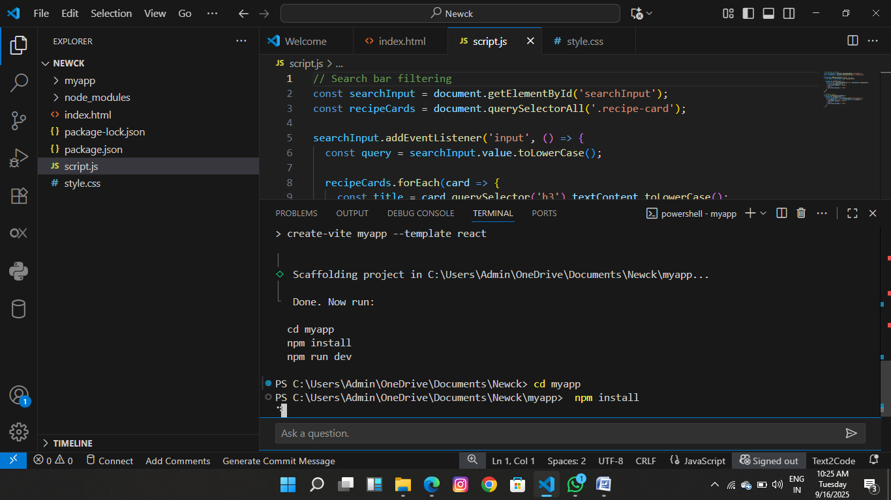

**Set -up Instructions:**

**1. Define the Scope and Audience:**

* **What's the purpose?** Is it for new users, experienced developers, or a specific team?
* **What problems does it solve?** Identify the common tasks and challenges that people face.
* **Who is the target audience?** Tailor the language, technical level, and examples to their needs.

**2. Structure the "Cookbook":**

* **Table of Contents:** Create a clear, well-organized table of contents. You can categorize by topic, task type, or level of difficulty.
* **Recipes:** Each entry in the cookbook should be a "recipe." A good recipe should have:
  + **Title:** A clear and concise name for the task (e.g., "Installing a new package," "Configuring the database connection").
  + **Problem Statement:** A brief description of the problem the recipe solves. This helps users quickly determine if it's the right solution for them.
  + **Ingredients (or Prerequisites):** List all the necessary tools, software, or files required to complete the task.
  + **Instructions:** Provide step-by-step instructions. Use clear and simple language, and number the steps for easy reference.
  + **Code Examples/Screenshots:** Include code snippets, command-line examples, or screenshots to illustrate the steps.
  + **Expected Outcome:** Describe what the user should see or what the result should be after completing the steps.
  + **Variations/Troubleshooting:** Offer alternative solutions, tips, or common issues and how to resolve them.
  + **Notes:** Add any additional information or context that might be helpful.

**3. Choose a Tool/Platform:**

* **Simple:** For small projects, you can use a simple document editor like Google Docs or Microsoft Word, or a markdown file in a Git repository.
* **Collaborative:** Tools like Confluence, Notion, or a company wiki are great for team collaboration.
* **Code-focused:** If your documentation is for a software project, consider a documentation generator like Sphinx, MkDocs, or Read the Docs. These tools can automatically generate a professional-looking website from your source files.
* **Specialized:** For specific use cases, there are tools built for creating this kind of documentation, such as those related to Chef cookbooks or other configuration management systems.

**4. Writing the Content:**

* **Consistency is Key:** Use a consistent format, tone, and language throughout the documentation.
* **Be Specific:** Avoid vague or ambiguous language. For example, instead of "run the program," say "run the command python script.py."
* **Use Headings and Formatting:** Use headings, subheadings, bullet points, and bold text to make the content scannable and easy to read.
* **Review and Edit:** Have someone else read your documentation to ensure clarity and accuracy. It's easy to overlook your own mistakes.

**5. Maintenance and Updates:**

* **Keep it Current:** Regularly review and update the recipes to reflect changes in software, processes, or best practices.
* **Solicit Feedback:** Encourage users to provide feedback on the documentation. This can help you identify areas for improvement and new recipes to add.

**Folder Structure**

* **Cookbook app/**
* **│── src/**
* **│ ├── App.js → Main application logic (state + functions + layout)**
* **│ ├── components/ → Reusable components folder**
* **│ │ ├── cook recieps Form.js → Form to add new items (name + picture)**
* **│ │ ├── foodList.js → Shows list of all inventory items**
* **│ │ └──foodstyle Item.js → Handles single item (pictures+ food style)**
* **│ ├── index.js → Entry point of React app (renders <App />)**
* **│ └── App.css → Styling for your app**

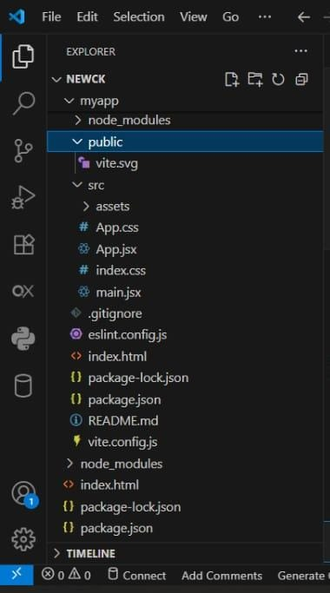

### Run the Application:

### Frontend:

### Prerequisites

* **Node.js and npm:** Most modern frontend projects (like those built with React, Vue, or Angular) require **Node.js** and its package manager, **npm**, to manage dependencies and run development servers. You can check if they're installed by opening your terminal and typing node -v and npm -v. If they aren't installed, download them from the official Node.js website.
* **VS Code:** You'll need VS Code itself, of course. If you haven't installed it yet, get it from the official VS Code website.

### Step-by-Step Guide

#### 1. Open the Project in VS Code

First, open the folder containing your frontend project in VS Code. You can do this by going to **File > Open Folder...** and selecting your project's root directory.

#### 2. Install Project Dependencies

Many projects will have a package.json file that lists all the necessary libraries and frameworks. To install them, open the **integrated terminal** in VS Code by going to **Terminal > New Terminal** or by pressing Ctrl + (the backtick key).

In the terminal, run the following command:

Bash

npm install

This command reads the package.json file and downloads all the listed dependencies into a new node_modules folder.

#### 3. Run the Development Server

The package.json file also contains scripts that define common tasks, like starting the application. The most common script for a development server is start. You can check the package.json file to see what scripts are available under the "scripts" section.

To run the application, type the following command in the terminal:

Bash

npm start

This command executes the start script, which usually **launches a local development server. The terminal will provide a** URL (like http://localhost:3000) where you can view your application in your web browser. This server often includes **hot-reloading**, meaning any changes you save to your code will automatically update in the browser without a manual refresh.

#### 4. Debugging (Optional)

VS Code has built-in debugging tools that can be very helpful. To set up a debugger, you might need to create a launch.json file in a .vscode directory within your project. This file configures how VS Code should launch and attach to the running application. You can often find pre-made debug configurations in project templates or by searching for extensions.

By following these steps, you'll be able to successfully run and work on your frontend project within the VS Code environment.

**Backend:**

**Step 1: Install a Language-Specific Extension**

VS Code is highly extensible. Before you do anything else, install the relevant extension for your backend language from the **Extensions** view (Ctrl+Shift+X). For example:

* **Node.js/JavaScript:** The base VS Code installation has built-in support, but for more advanced features like linting and debugging, you'll benefit from extensions like the Node.js Extension Pack.
* **Python:** Install the official **Python** extension by Microsoft. This is crucial as it provides a vast array of tools, including linting, debugging, and virtual environment management.
* **Java:** Install the **Extension Pack for Java**, which includes a debugger, a test runner, and a project manager.

**Step 2: Open the Project and Install Dependencies**

Open your project folder in VS Code. Just like with a frontend project, most backend projects rely on a package manager to handle dependencies.

* **Node.js:** Open the integrated terminal (Ctrl+) and run npm install (or yarn install or pnpm install) to install the packages listed in your package.json file.
* **Python:** If your project uses a virtual environment, activate it in the terminal first. Then, install dependencies from your requirements.txt file by running pip install -r requirements.txt.
* **Java:** Projects often use build tools like **Maven** or **Gradle**. When you open a project with a pom.xml (Maven) or build.gradle (Gradle) file, the Java extensions will automatically detect it and download the necessary dependencies.

**Step 3: Run the Application**

The command to run your backend application depends on the language and framework.

* **Node.js:** Check the scripts section in package.json. The command is often npm start or npm run dev.
* **Python:** You might run the main file directly using python <filename>.py or use a specific command for your framework, such as flask run or uvicorn main:app --reload.
* **Java:** Use the **Java Projects** view in the sidebar to find your project's main class and run it. Alternatively, you can use Maven or Gradle commands in the terminal, like mvn spring-boot:run for a Spring Boot application.

**Step 4: Debugging (Optional but Recommended)**

VS Code's debugger is a powerful tool for backend development. To use it, you'll typically need to create a **launch.json** file in a .vscode directory within your project. This file configures the debugger. You can generate a default configuration by going to the **Run and Debug** view (Ctrl+Shift+D) and clicking the link to create a launch.json file. From there, you can set breakpoints, step through your code, inspect variables, and much more.

This video provides a comprehensive guide to setting up VS Code for backend development with Node.js, including a detailed look at the extensions and settings that can improve your workflow.

### 1. Landing Page

**Step 1: Define Your Goals and Audience**

Before you write a single line of code or design anything, you need a clear vision.

* **Who is your audience?** Are you targeting busy parents, aspiring home chefs, vegans, or people on a specific diet? Knowing your audience will influence your design, tone, and the types of recipes you feature.
* **What is the purpose of the landing page?** Is it to:
  + Promote a physical or digital cookbook?
  + Grow an email list for a newsletter?
  + Get users to sign up for a recipe-sharing platform?
  + Showcase a few key recipes from a collection?

**Step 2: Plan Your Content (The "Ingredients")**

A good landing page follows a simple, compelling narrative. Here are the key sections you should include:

1. **Hero Section:** This is the first thing users see. It should be visually striking and instantly tell them what the project is about.
   * **Headline:** A clear and catchy title. (e.g., "The Ultimate Guide to Plant-Based Cooking," "Quick Weeknight Meals for the Modern Family").
   * **Sub-headline:** A brief sentence that expands on the headline.
   * **Call-to-Action (CTA):** A prominent button that guides the user to the next step. (e.g., "Buy the Cookbook," "Sign Up for Updates," "Explore Recipes").
   * **High-Quality Image/Video:** A beautiful, mouth-watering photo or a short video of a finished dish.
2. **Problem/Solution:** Explain the problem your cookbook solves.
   * *Problem:* "Tired of searching for healthy recipes that your family will actually eat?"
   * *Solution:* "Our cookbook offers simple, delicious, and healthy meals for every day of the week."
3. **Features/Benefits Section:** Highlight what makes your cookbook or project unique.
   * **Features:** What it *is* (e.g., "100+ recipes," "step-by-step instructions," "easy-to-find ingredients").
   * **Benefits:** Why those features matter to the user (e.g., "Save time in the kitchen," "Cook like a pro," "Never eat a boring meal again").
4. **Recipe Showcase:** Feature a few of your best or most popular recipes.
   * Include high-quality images.
   * Give a brief, enticing description for each.
   * Link to the full recipe page if it exists.
5. **Social Proof:** Build trust and credibility.
   * **Testimonials:** Quotes from satisfied readers or early testers.
   * **Media Mentions:** Logos of magazines, blogs, or news outlets that have featured your work.
   * **Reviews/Ratings:** Show star ratings or a number of positive reviews.
6. **About the Author/Team:** Tell your story and connect with your audience on a personal level.
   * A professional headshot.
   * A brief bio explaining your passion and expertise.
7. **Final Call to Action (CTA):** A strong, final push to get the user to convert. This is a good place to offer an exclusive discount or a special bonus.
8. **Footer:** Include essential links like social media, contact information, privacy policy, and terms of service.

**Step 3: Design the Landing Page**

* **Minimalist Design:** Use plenty of white space to make your content easy to read and your photos stand out.
* **Color Palette:** Choose a color scheme that reflects the project's theme. Warm, earthy tones are great for a cozy, family-focused cookbook, while bright, vibrant colors work well for a modern, experimental one.
* **Typography:** Select fonts that are easy to read and complement the overall design. Use one font for headlines and another for body text.
* **High-Quality Images:** This is non-negotiable for a food-related project. Use professional, well-lit photos.

**Step 4: Build It (The "Cooking" Process)**

You have several options for building the landing page, depending on your technical skills.

* **No-Code Builders:**
  + **Canva:** Offers a user-friendly drag-and-drop interface with many pre-designed cookbook templates. It's a great option for a fast, simple landing page.
  + **Wix, Squarespace, or Webflow:** These platforms offer more flexibility and powerful features for building a professional website without coding.
* **Coding:**
  + If you're comfortable with HTML, CSS, and JavaScript, you can build a custom landing page for complete control over the design and functionality. This is a great exercise for a developer.
  + **Frameworks/Libraries:** Use a frontend framework like React, Vue, or Angular, or a static site generator like Next.js or Gatsby, to build a more complex and scalable landing page.

**Step 5: Launch and Promote**

Once your landing page is built, don't just let it sit there.

* **Test it:** Make sure it's fully responsive and looks great on all devices (mobile, tablet, desktop).
* **Drive traffic:** Share the link on your social media channels, include it in your email signature, and mention it on any relevant blogs or forums.
* **Analyze and optimize:** Use tools like Google Analytics to track how users interact with your page and make improvements to increase conversions.

2.Admin Panel.

• **Dashboard:** A high-level overview of your site's performance.

* **Statistics:** Display key metrics like the total number of recipes, registered users, and comments.
* **Recent Activity:** Show a log of the latest recipes added, comments received, or users who have signed up.

• **Recipes Management:** This is the most crucial part of the admin panel.

* **Create/Edit/Delete Recipes:** A user-friendly form to add new recipes with all their details.
  + **Title and Description:** For the recipe's name and a short summary.
  + **Ingredients:** A structured list with quantities and units (e.g., "1 cup of flour").
  + **Instructions:** A step-by-step guide, possibly with the ability to add images or videos to each step.
  + **Categories/Tags:** Fields to categorize recipes by cuisine (e.g., Italian, Mexican), meal type (e.g., breakfast, dessert), or dietary needs (e.g., vegetarian, gluten-free).
  + **Metadata:** Fields for cooking time, serving size, and difficult
  + **Featured Image:** An easy way to upload and manage the main photo for the recipe.

• **Categories & Tags Management:** A dedicated section to manage the categories and tags used to organize your recipes. This allows you to easily create, edit, or remove them without changing individual recipes.

• **User Management:** If your project allows user accounts for features like saving favorite recipes or submitting their own, you'll need this section.

* **View Users:** A list of all registered users.
* **Manage Roles:** Ability to assign different roles, such as a "contributor" who can submit recipes for review.
* **Permissions:** Control what each user role can do on the site.

• **Comments & Ratings Management:** A section to moderate user comments and ratings.

* **Review:** Easily approve, edit, or delete comments.
* **Spam Filtering:** Tools to automatically flag or remove spam.

• **Media Library:** A central location to manage all the images and videos used on the site.

* **Upload/Delete Media:** Add or remove media files.
* **Image Optimization:** Built-in tools to compress images for faster page loading.

About the cook book:

This cookbook project is a dynamic digital platform that transcends the traditional recipe blog by fusing culinary artistry with interactive technology. It’s a curated library of chef-quality recipes presented with stunning photography and step-by-step video guides, designed not just to instruct, but to inspire. The platform’s unique feature is its smart recipe scaling, which dynamically adjusts ingredient quantities based on serving size and allows users to seamlessly convert units, making cooking effortless and personalized. Beyond the kitchen, it fosters a vibrant community where home chefs can share their creations, rate dishes, and submit their own recipes, transforming a simple cookbook into an ever-evolving, collaborative hub for food lovers.

Testing:

Testing a cookbook paragraph involves a meticulous review to ensure it effectively guides a home cook. In detail, this goes beyond simple proofreading to a comprehensive evaluation of its functionality. First, you're verifying for **clarity and conciseness**, checking that the language is simple and direct, avoiding jargon or overly long sentences that could confuse a reader mid-recipe. The paragraph's **accuracy** is paramount—this means confirming that the steps are in the correct, logical sequence and that all referenced ingredients are listed and used appropriately. Next, you're assessing **completeness**, asking if the paragraph provides all the necessary information without making assumptions about the reader's prior knowledge; for example, does it specify to "chop" or "slice" an ingredient, and does it include a crucial step like preheating an oven? Finally, you're evaluating its overall **readability and tone**, ensuring the writing style is consistent with the rest of the book—whether it's a warm, conversational guide or a more technical, professional instruction set—and that the flow is smooth, making the cooking process feel like a natural progression rather than a chore. The ultimate test is whether a person can follow the instructions precisely as written and achieve the desired result, making this type of testing as much about practical application as it is about literary review.

**Screenshots:**

­­­­­­­­

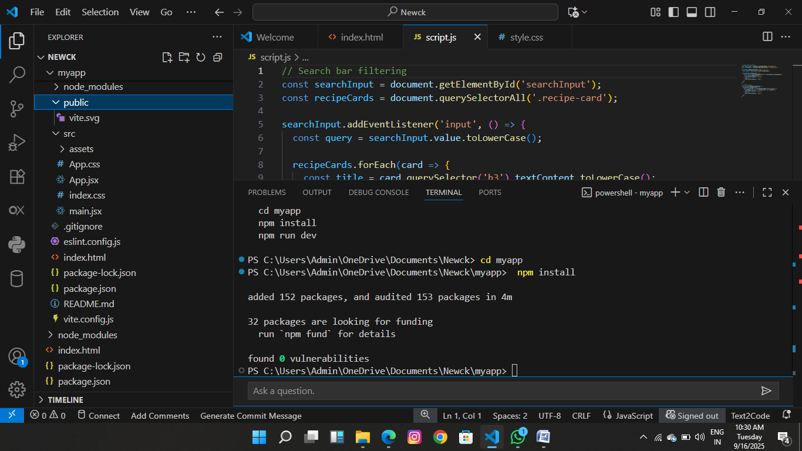

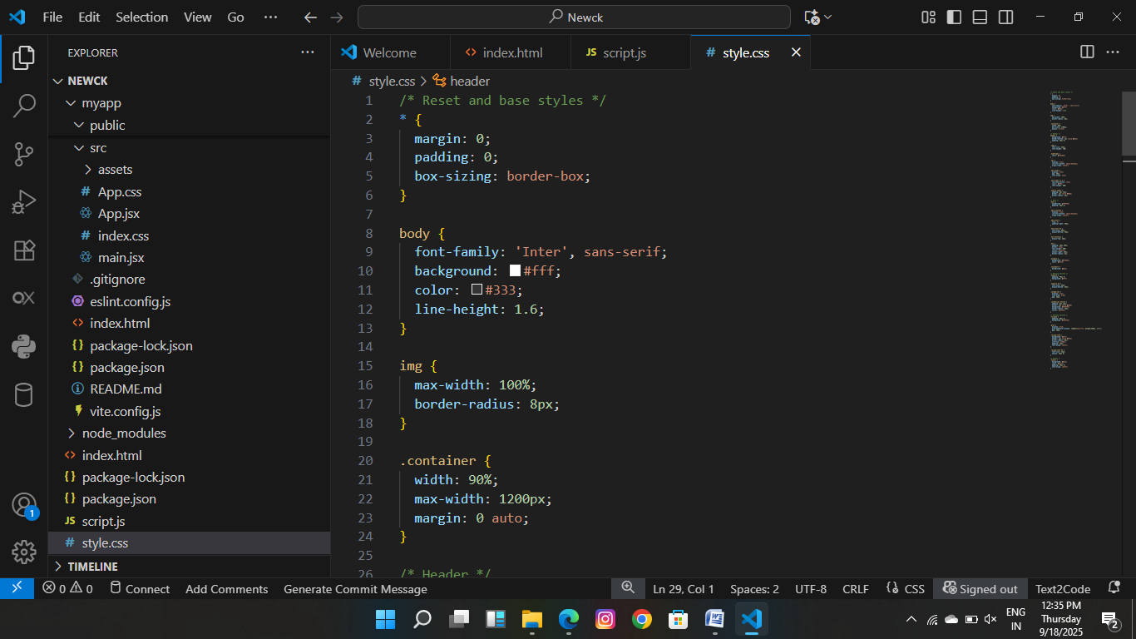

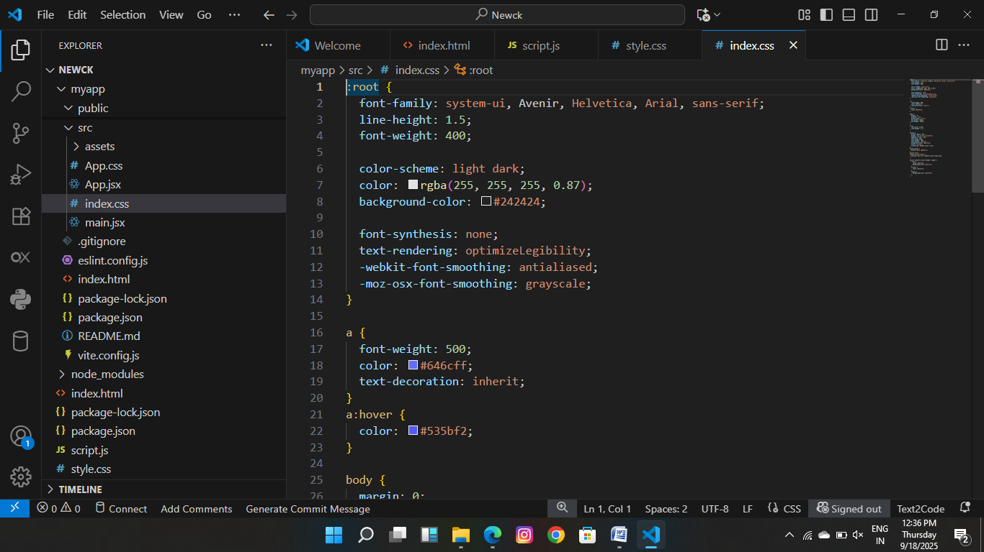

THANK YOU